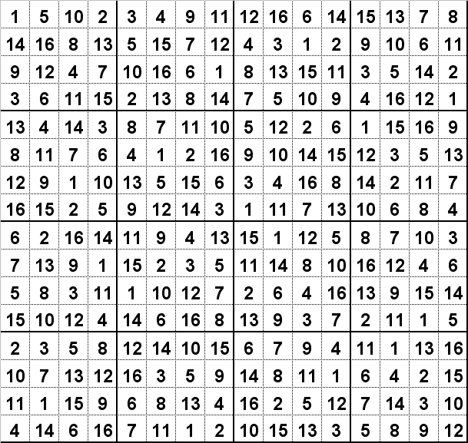

More Sudoku Puzzles can be found at: www.sudoku.4thewww.com

