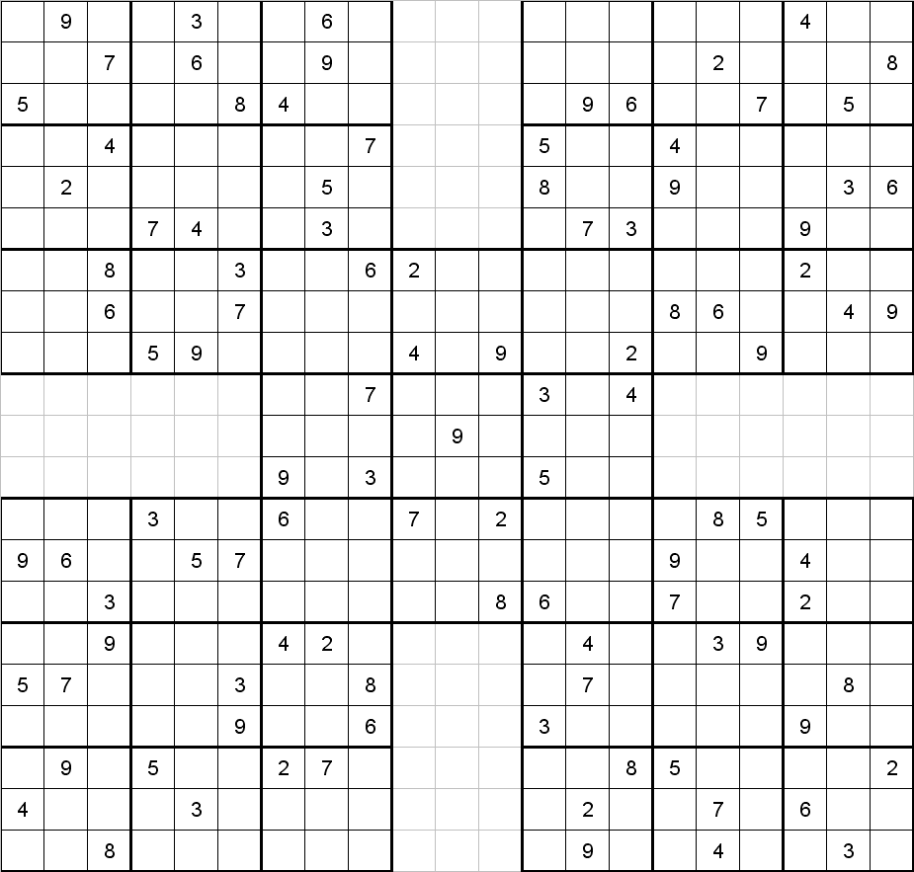

Solution to this puzzle can be found at: www.sudoku.4thewww.com

