Killer Samurai 2 Solution

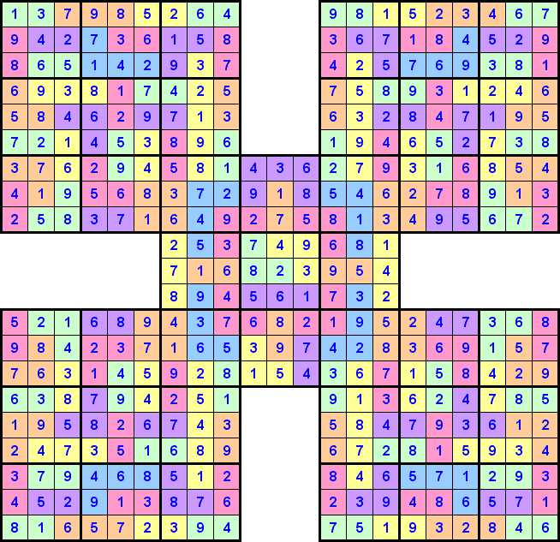

More ‘Killer Samurai’ Sudoku Puzzles and the solutions can be found at http://www.sudoku.4thewww.com

Enjoy

