Killer Samurai 10 Solution

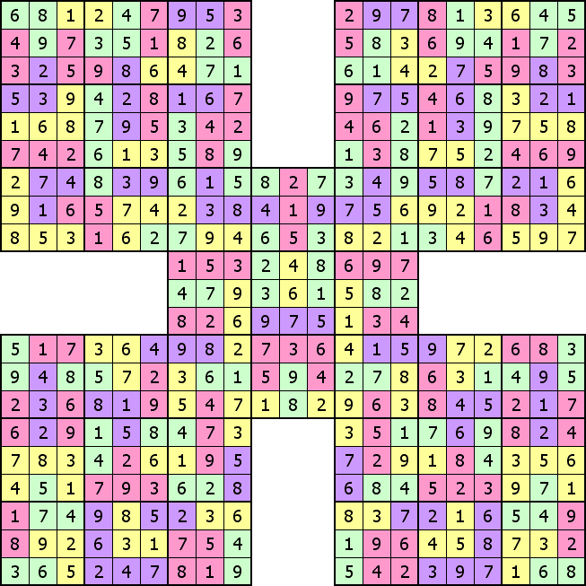

More ‘Killer Samurai’ Sudoku Puzzles and the solutions can be found at http://www.Killer-Samurai.com

Enjoy

